**Unveiling the Power of MailSurge: A Comprehensive Study on Cutting-Edge Email Automation**

**A project report.**

Submitted in partial fulfilment of the requirements for the award of degree of

**Bachelor Of Technology in Computer Science and Engineering (Honors)**

**Submitted to**

**LOVELY PROFESSIONAL UNIVERSITY**

**PHAGWARA, PUNJAB**



From 06/26/2024 to 07/26/2024

SUBMITTED BY

**Name of students**                                                                          **Name of Supervisor**

                                                                                                       Kajal Gupta

Amit Kumar (11805621)

**(APPROVAL ATTACHMENT)**

Declaration by student

To whomsoever it may concern,

I Amit Kumar hereby declare that the work done by me on “Unveiling the Power of MailSurge: A Comprehensive Study on Cutting-Edge Email Automation” under the supervision of Kajal Gupta, Assistant Professor, Lovely professional University, Phagwara, Punjab, is a record of original work for the partial fulfilment of the requirements for the award of the degree, Bachelor of Technology in Computer Science and Engineering.

Name of the Student

Amit Kumar

11805621

Dated

26/07/24

Signature of the student

**Annexure-VI**

Declaration by the supervisor

To whomsoever it may concern

This is to certify that Amit Kumar from Lovely Professional University, Phagwara, Punjab, has worked on “Unveiling the Power of MailSurge: A Comprehensive Study on Cutting-Edge Email Automation” under my supervision from. It is further stated that the work carried out by the student is a record of original work to the best of my knowledge for the partial fulfilment of the requirements for the award of the degree, degree name.

Name of Supervisor

Kajal Gupta

Assistant Professor

UID of Supervisor

31199

Signature of Supervisor

**List Of Contents**

|  |  |  |
| --- | --- | --- |
| **S. No.** | **Title** | **Page** |
| 1 | **Topic Approval** | **2** |
| 2 | **Declaration by Students** | **3** |
| 3 | **Declaration by Supervisor** | **4** |
| 4 | **Acknowledgement** | **6** |
| 5 | **Chapter 1 - Introduction** | **7** |
| 6 | **Chapter 2 - Definition** | **7** |
| 7 | **Chapter 3 - Benefits** | **7** |
| 8 | **Chapter 4 - Features** | **8** |
| 9 | **Chapter 5 – Technologies Used** | **11** |
| 10 | **Chapter 6 – Project Novelity** | **14** |
| 11 | **Chapter 7 – Future Scope** | **15** |
| 12 | **Conclusion** | **15** |
| 13 | **Originality Report** | **16** |

**ACKNOWLEDGEMENT**

I want to express our deepest gratitude to every individual who contributed their expertise, dedication, and support to the successful completion of this project. Their unwavering commitment and invaluable guidance were instrumental in ensuring the success of our study.

I am immensely grateful to our institution for providing the necessary resources, infrastructure, and a conducive environment for conducting our research. The mentorship and support provided by our supervisor were pivotal in shaping the direction and methodology of our study, and we sincerely appreciate their insights and encouragement. Furthermore, we extend our heartfelt thanks to fellow classmates whose cooperation and active involvement were essential in gathering the data and insights crucial to our research. Their willingness to share their experiences greatly enriched the depth and quality of our study.

I also want to express our sincere appreciation to my mentor, Ms.Kajal Gupta , whose unwavering support, wisdom, and encouragement guided us throughout our study. Her expertise and mentorship have been invaluable, inspiring us to aim for excellence and push our boundaries.In conclusion, we acknowledge the collaborative efforts and collective spirit that made this project possible. We deeply appreciate the contributions of all involved and look forward to further exploration and discovery together.

**1. Introduction**

Effective and secure email communication is essential for businesses and organizations in the modern digital age that want to keep their audience engaged. A sophisticated software program called MailSurge is introduced to address the expanding need for bulk email automation. Through a smooth integration with the Gmail API, MailSurge gives users the ability to send customized emails with attachments while taking advantage of the increased security and privacy provided by random proxy servers. This paper explores MailSurge's extensive capabilities, emphasizing its features, advantages, unique project, potential, and overall importance.

**2.Definition**

Personalized emailing is made easier with MailSurge, an innovative mass email automation application that makes use of the Gmail API. It has features that allow you to connect different kinds of files, so complete communication is guaranteed. One of MailSurge's best features is that it can employ proxy servers, which give the sender an additional strong layer of security and anonymity. For companies and organizations engaged in substantial email marketing campaigns or large-scale email interactions, this makes it a priceless tool.

**3. Benefits**

Efficiency: MailSurge automates bulk email sending, which would otherwise take a long time. Large email campaigns can be easily managed by users, greatly minimizing the human work required to create and send each email.  
  
Personalization: By enabling the modification of email content, the software enables the creation of tailored messages that improve recipient engagement. In email marketing, this personal touch is essential because it can result in better response and open rates.  
  
Security: MailSurge guarantees the sender's anonymity and security by incorporating proxy server capability. This is especially helpful in shielding confidential data and the sender's identity from possible dangers.

Flexibility: MailSurge can handle a wide range of attachment formats, including PDFs, PNGs, JPGs, and more. Thanks to this versatility, users may write interesting and thorough emails that meet a variety of communication objectives.  
  
Cost-effective: MailSurge lessens the need for pricey email marketing agencies by using the Gmail API. Its ability to save costs makes it a desirable option for companies of all kinds.

**4. Features**

Gmail Authentication: MailSurge's OAuth2 integration with Gmail provides safe authentication. Users may utilize their Gmail accounts to send large numbers of emails without sacrificing security thanks to this smooth integration.

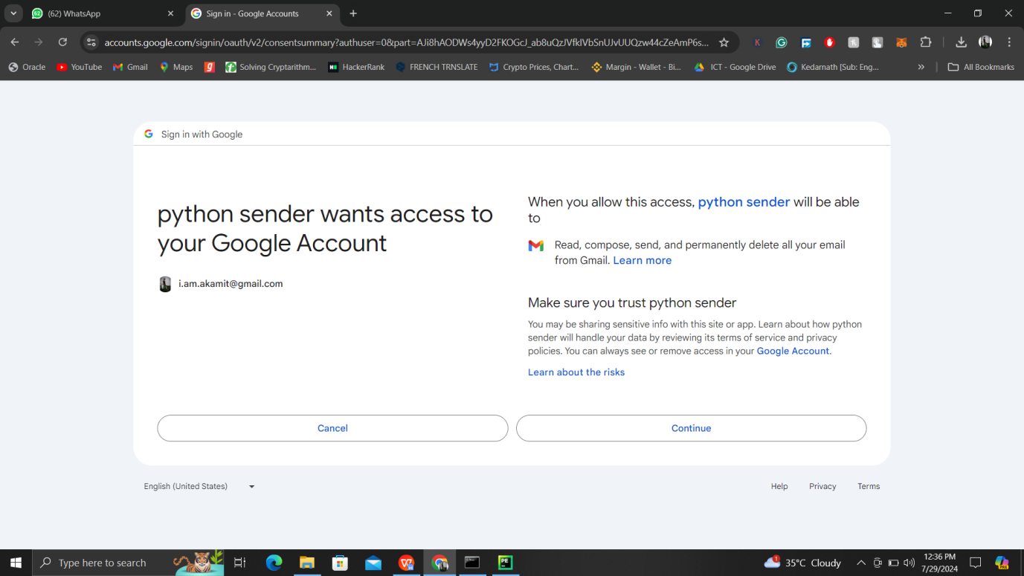

Support for Proxy Servers: The program has options for connection and random proxy selection. Emails are sent through several proxy servers, which improves security and protects sender anonymity.

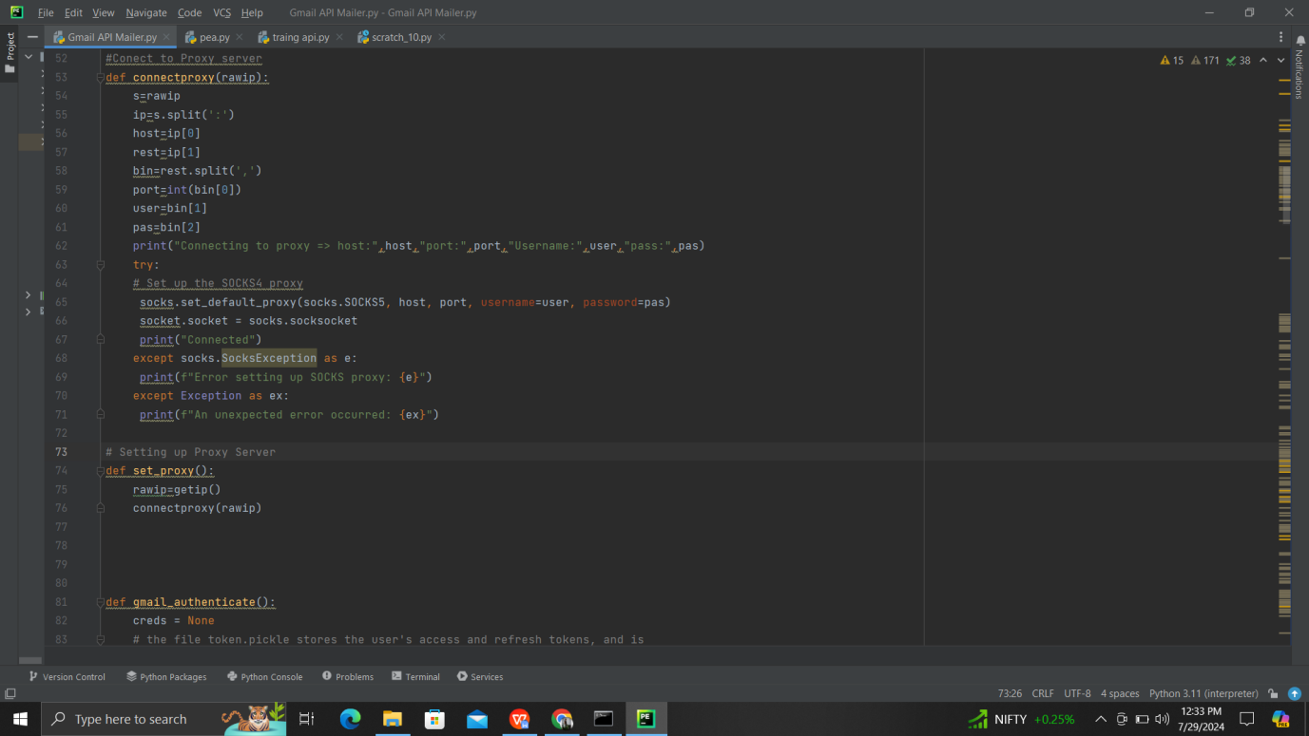

MailSurge is capable of handling a wide range of attachment formats, including PDFs, pictures, audio files, and other file kinds. Users can send rich and descriptive emails with this feature.

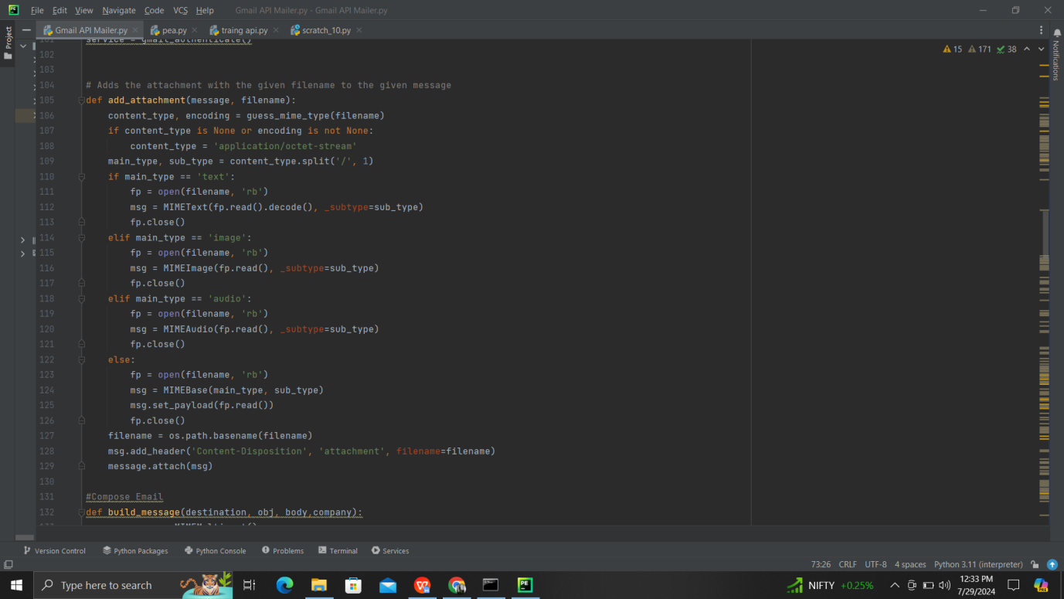

Email Personalization: Users can include dynamic subjects lines and personalized recipient names to their emails. This function contributes to the development of a more interesting and tailored communication experience.

Template Management: To guarantee that recipients receive a variety of interesting content, the program allows for the random selection of email templates. This lessens the possibility that emails may be classified as spam.

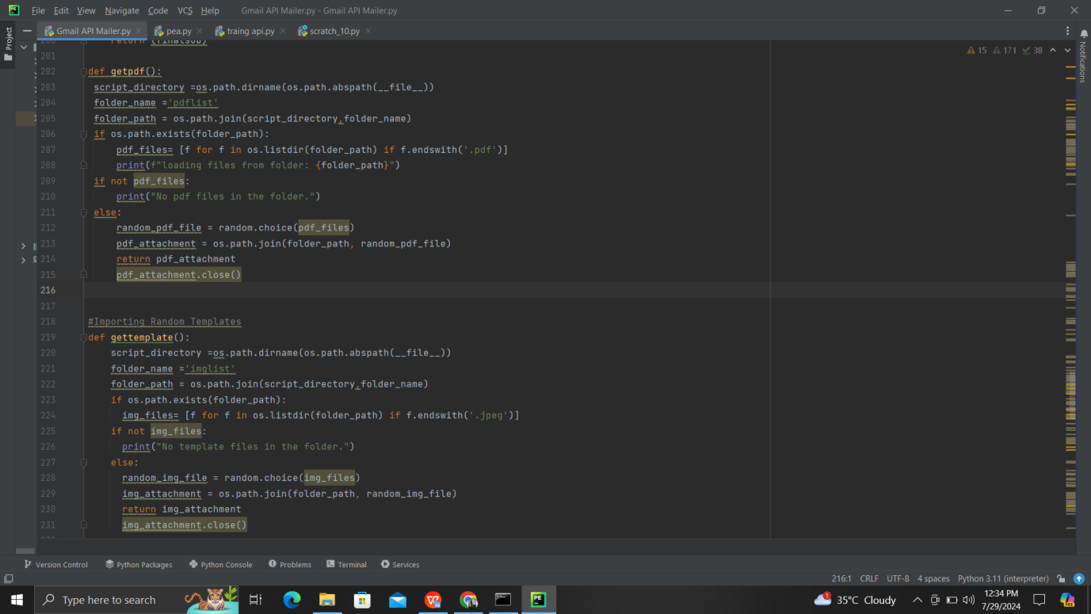

CSV Import: MailSurge makes it simple to import recipient lists from CSV files, which makes managing big email lists easier.

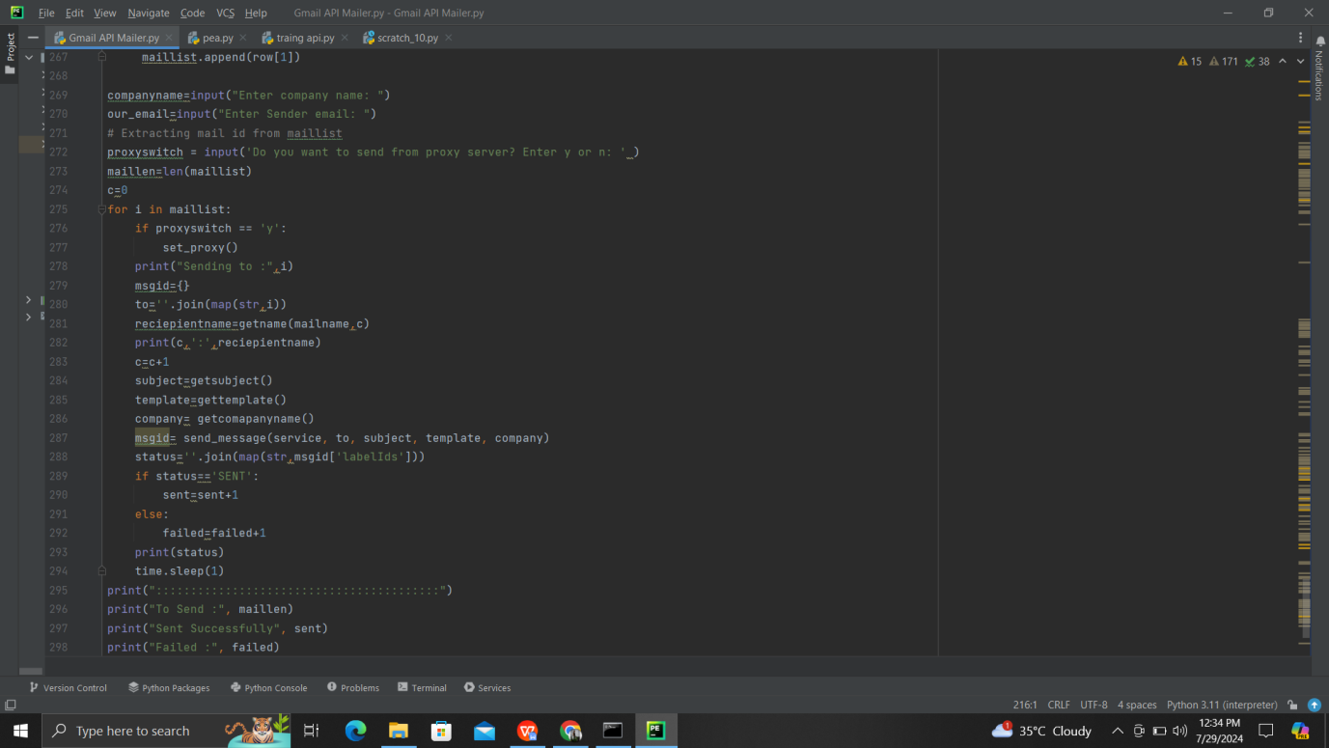

Status Reporting: The application keeps track of and provides information on the sent emails, such as whether they were sent successfully or not. Users can monitor and analyze their email campaigns with the use of this function.

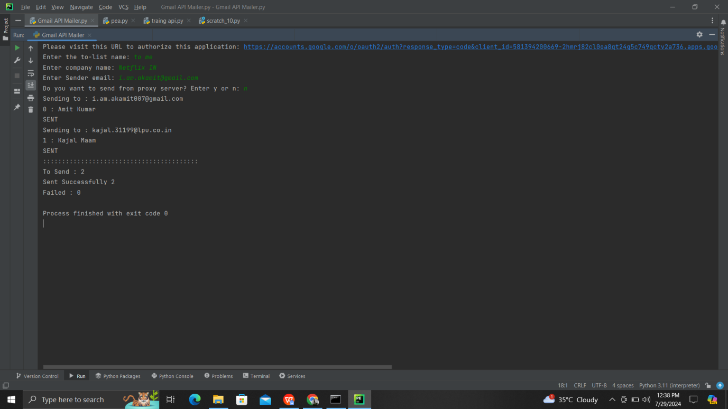

Unsubscribe Header: To ensure that recipients may quickly opt-out if they so choose, every email includes an unsubscribe link in compliance with email marketing standards.

1. **Technologies Used:**

**Programming Languages and Libraries**

Python: The primary language used to construct MailSurge, due to its ease of use and rich library support.

Google_auth_oauthlib and Googleapiclient: For managing OAuth2 authentication and connecting with the Gmail API.

Faker: Produces arbitrary data in order to customize emails.

**Email Handling**

Email and MIME Libraries: Constructs emails with various content types and attachments.

Base64: Encodes and decodes messages for Gmail API compatibility.

**Proxy Management**

Socks and Socket: For increased security, configures and controls connections via SOCKS5 proxies and ip rotation.

**Data Handling**

CSV: Opens CSV files and reads the recipient lists.

OS: Dynamically manages directories and file paths.

**Authentication and API Integration**

Googleapiclient.discovery: Constructs and communicates with Gmail.

Google_auth_transport_requests: refreshes OAuth2 tokens.

**Randomization and Automation**

Random: Selects random email templates, subjects, and proxies.

Time: Introduces delays between sends to mimic human-like behavior.

**File Handling**

Mimetypes: Guesses MIME types of attachments.

Pickle: Saves and loads OAuth2 tokens securely.

**Software Environment**

· Operating System: Cross-platform compatibility.

· Development Environment: Python-friendly IDE for efficient coding and debugging.

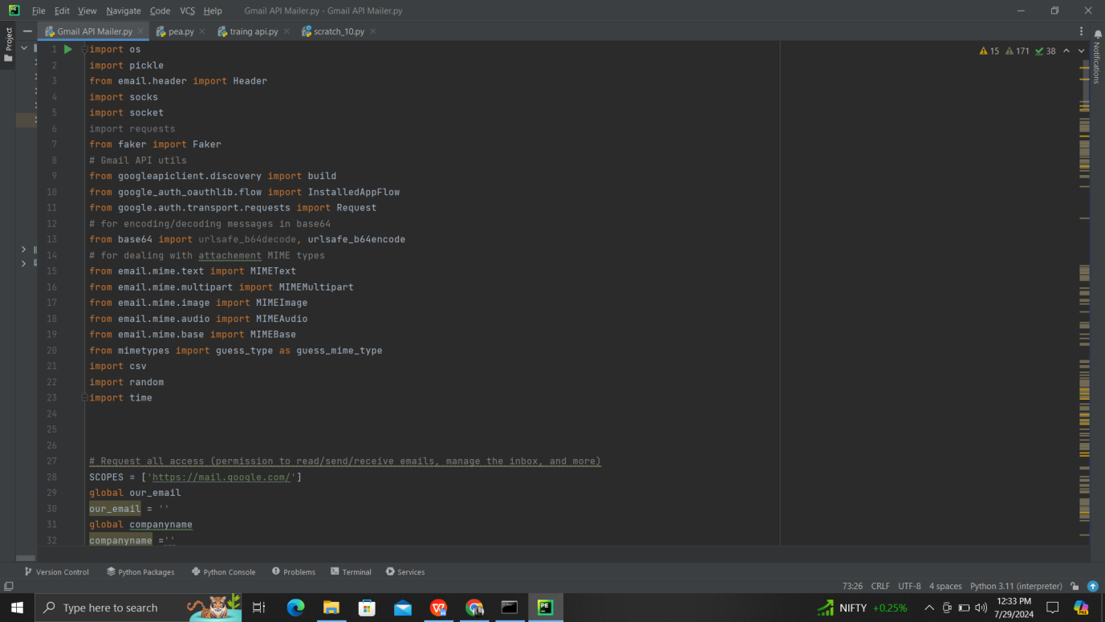

**Upcoming Enhancements**

Advanced Analytics Tools: For tracking email performance metrics.

GUI Frameworks: To develop a user-friendly graphical interface.

Spam Filtering Algorithms: To ensure high deliverability rates.

MailSurge provides a reliable and effective email automation solution designed for contemporary companies and organizations by utilizing these tools and technology.

1. **Project Novelty:**

MailSurge sets itself apart with its special blend of cutting-edge functionality and approachable style. Adding different proxy servers to every email sent is a creative solution that greatly improves security and privacy. Furthermore, the software's capacity to choose email subjects and templates at random guarantees that every receiver gets interesting and original information, significantly lowering the possibility that emails will be reported as spam.  
  
A noteworthy feature of MailSurge that distinguishes it from many other bulk email solutions is how well it handles attachments. This functionality meets a variety of communication demands by enabling users to send rich and descriptive emails. The tool's ability to customize email content to a great extent adds to its distinctiveness and makes it an effective option for companies looking to sustain significant audience engagement.

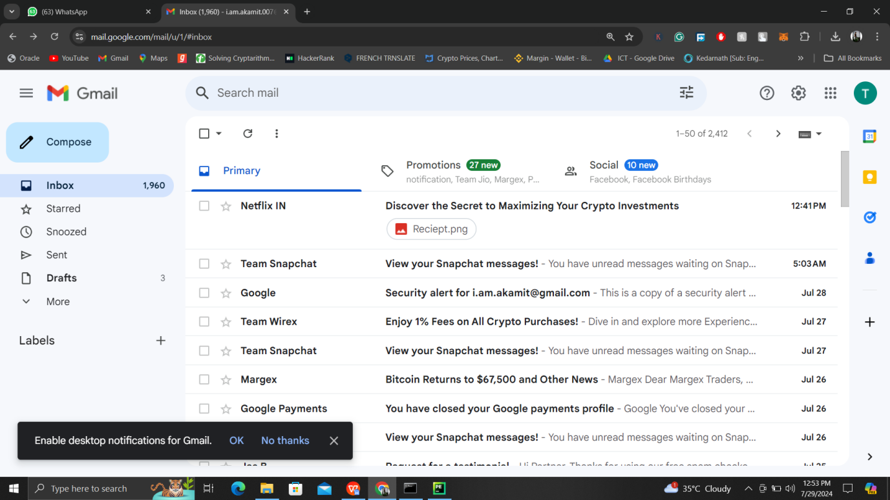

**6. Future Scope:**

MailSurge has a great deal of room for improvement and development. The tool could be made even more reliable and adaptable in the future by implementing the following improvements:  
  
Advanced Analytics: By incorporating advanced analytics, users may monitor important data like click-through rates, open rates, and other signs of user engagement. Email marketing could be optimized with the use of this data-driven strategy to achieve higher performance.  
  
Better Proxy administration: The security and dependability of the tool may be further increased with improvements in proxy administration, such as automatic proxy rotation and health checks.

Customization of Templates: Including a built-in template editor would enable users to add further personalization and engagement by enabling them to design and modify their own email templates.  
  
API Integration: MailSurge would become a more flexible tool that serves a wider spectrum of customers if it were to support various email services and APIs in addition to Gmail.  
  
User Interface: By adding a graphical user interface (GUI), the tool's user base would increase by making it easier for non-technical users to utilize.  
  
Spam Filtering: To ensure high deliverability rates and lower the chance of emails being flagged as spam, spam filtering algorithms should be put into place.

**7. Conclusion:**

MailSurge is a potent and effective technology that will completely change the way bulk email campaigns are managed. With features like tailored content, proxy server support, and extensive attachment handling, along with its smooth connection with the Gmail API, it's a great tool for companies and organizations. Users may handle their email exchanges efficiently and securely thanks to the software's special blend of cutting-edge capabilities and user-friendly design. With continued improvement and development, MailSurge has the potential to emerge as a top email marketing and automation tool, assisting companies in effectively and conveniently meeting their communication objectives.

